CASE 4: MANAGEMENT OF AN INGROWN TOENAIL: CONSEQUENCE OF WEARING ILL-FITTED SHOE.

Name: E.J Marital Status: Married Hosp No.: 83479

Age: 39 years Address: Ojodu, Lagos Date Seen: 2/12/2022

Sex: Male Religion: Christianity Date Last Seen:

Occupation: Computer Scientist Tribe: Hausa

Presenting Complaints: Pain and swelling in the left big toe of 6 months’ duration

History of Presenting Complaints: EJ presented at the clinic with pain and swelling in his left big toe which began six months prior. The pain was of gradual onset, rated 6 out of 10 on the Numerical Pain Scale, dull aching in nature, intermittent, did not radiate and was not referred to any other body parts. It was aggravated by movement, wearing of his office boot and relieved by using analgesics. There was positive history of swelling, redness, and discharge. There was no joint swelling or pain in other parts of the body. There was no history of trauma. He had no fever. Since onset of symptoms, he presented in a clinic where he received unspecified oral and topical analgesics with little relief. There was a history of a similar occurrence about a 8 months ago when he was gifted a shoe smaller than his usual size, but no treatment was sought at that time because it resolved spontaneously.

EJ was afraid that the pain might cause him to start limping if it continued. He knew the shoe caused it because the shoe was his favourite. This has affected his work which required him shuttling between departments and walking was painful and the pain prevented him from being able be smart in the course of his duty. He wanted a cure for his condition because he was afraid, he could lose his toe.

Review of Systems: There was no history of headache, dizziness, breathlessness, chest pain, vomiting or abdominal pain.

Past Medical History: There was no history of hypertension, diabetes, asthma or epilepsy. There was no previous surgery, blood transfusion or hospital admission.

Drug and Allergy History: There was no known drug/other allergy. He is not on any medication.

Family and Social History: E.J was married with two children in a monogamous family setting which was a family with school children stage according to Duvall family model. His wife was a trained teacher but still unemployed and searching for a rewarding employment. His family lived in a two-bedroom flat with well-ventilated rooms and water closet facilities. Their source of drinking water was borehole, sewage disposal by water closet while solid waste disposal was by LAWMA. He does not smoke but occasionally takes alcohol (he is a social drinker).

General physical examination: EJ was afebrile with an axillary temperature of 36.7oC, anicteric and not cyanosed. He was not pale and not dehydrated. There were no palpable peripheral lymph nodes and no pedal oedema. His weight was 72kg and his height was 1.75m. The body mass index was 23.5Kg/m2 which was normal.

Musculoskeletal System: There was no gait abnormality or gross deformity of the limbs. There was no abnormality in the right foot. There was a firm, erythematous and tender swelling with ulceration and mild discharge on the lateral nail fold of the left hallux measuring about 0.8 by 0.6cm. There was no ulceration or discharge, but the swelling was mildly tender. There was no extension of swelling and tenderness to the rest of the foot. There were no other toe and foot deformities, no loss of sensation and the pulses in the dorsalis pedis and posterior tibial arteries were full and regular.

Ear, Nose and Throat examination: Both auricles were normal with no tragal tenderness. The nose, oropharynx and throat were normal.

Central Nervous System: EJ was conscious, alert and oriented in time, place and person. The cranial nerves were grossly intact. There was no motor or sensory loss in any part of the body and the reflexes were normal.

Respiratory System: EJ’s respiratory rate was 18 cycles per minute and the trachea was central. The chest expansion was symmetrical and tactile fremitus was normal. The breath sounds were vesicular with no added sounds.

Cardiovascular System: The pulse rate was 86 beats per minute, regular and of full volume. The blood pressure was 120/80mmHg. Only first and second heart sounds were heard.

Abdomen: The abdomen was full, moved with respiration and had no scar or scarification mark. It was soft and not tender. The liver and spleen were not palpable, and both kidneys were not ballotable. The bowel sounds were normoactive.

Diagnosis: Ingrown toenail in the left great toe

Psychosocial concerns: fear of abnormal gait and losing his toes, wearing ill-fitted shoes

Address the above in the management

Differential Diagnosis: Eccrine poroma and Paronychia.

Management: The diagnosis was explained to EJ and his concern of having gouty arthritis was allayed. He was given oral diclofenac plus misoprostol 75mg/200mcg to be used twice daily for a week. He was then counselled on the need for surgical intervention in the form of excision of the nail. He was informed about different procedural techniques and opted for a modified wedge resection of the nail. Informed consent was obtained, and he was booked for surgery on 13/12/2022.

Procedure: Partial nail avulsion with surgical matricectomy

EJ was placed supine on the examination couch in the minor theatre and venous access was gained. IV ciprofloxacin 200mg was given pre-operatively. The feet were re-examined to confirm the surgical site which was cleaned with povidone iodine. Draping was done to expose the left hallux and a digital block was done to anaesthesia the great toe with 3ml of plain 1% lignocaine. The finger of a pair of sterile latex gloves was improvised as a tourniquet and applied to the base of the left hallux. A 3mm-wide strip of nail was separated from the nail bed laterally using a small pair of artery forceps which was advanced proximally till just beyond the cuticle. A sharp pair of scissors was used to divide the nail all the way to its proximal extent and the lateral sliver of nail was grasped with some artery forceps. It was removed using a twisting motion and the underlying matrix was scraped clear using an artery forceps. The hyper granulation tissue at the lateral nail fold was completely excised and the resulting defect was sutured to the nail using nylon 0 sutures in interrupted fashion. The tourniquet was released, and the wound was dressed with a Sofra-Tulle or Povidone soaked gauze along with a firm overlying gauze held in place by a bandage. He was given intramuscular tetanus toxoid 0.5ml stat, oral ciprofloxacin 500mg twice daily and oral diclofenac plus misoprostol 75mg/200mcg twice daily for 72 hours. He was counselled to keep the foot dry and elevated for the next 72 hours and given a 48-hour follow-up appointment.

First Follow-up: Two days later (15/12/2022): The wound was inspected. It was clean and dry. The dressing was changed to a firm gauze bandage, and He was counselled on the use of open toed slippers and shoes. He was given a four-day follow-up appointment.

Second follow-up (19/12/2022): He was seen four days later, and the wound was clean and dry. He was counselled on the use of warm saline soak for 15 minutes once daily and taught how to replace the gauze bandage. He was also counselled on proper trimming of His nails and foot care. He was given a week follow-up appointment.

Third follow-up (27/12/2022): Fourteen days later, the wound was clean, dry and well healed. The stitches were removed, and His counselling reiterated. He had follow-up visits two weeks later to monitor His progress and later at three-monthly intervals to rule out recurrence of which none were found. He was discharged from follow-up after six months and asked to return if the problem recurred.

Summary: EJ was a 39-year-old Man who had recurrent episodes of ingrown toenail. He had partial nail avulsion with surgical matricectomy. He received counselling on foot care and did not have a recurrence.

Discussion: An ingrown toenail also known as onychocry ptosis or unguius incarnatus is a common nail problem occurring when the nail plate grows into the periungual skin and causes inflammation and infection.1 It is a common surgical condition of the foot causing pains as seen in EJ, disability, and absence from work.2 Previous reports have noted that the prevalence was as high as 2.5 to 5%.4 It has also been found to occur more often in teenagers and young adult males between the ages of 15 to 40 years; with a male to female ratio of 3:1.2,5 EJ is 39 years old. Three stages have been identified in the development of ingrown/embedded toenail namely: stage I, the inflammatory stage; stage II, the abscess formation stage; and stage III, the granulation stage.3 It’s diagnosis is a straight forward diagnosis. It has been associated with use of tight foot wears, congenital anomalies of nail folds, nail plates, and medial rotation of the great toes, diabetes, bad foot hygiene, obesity and cardiac disorders.2 E.J is neither diabetic, obese nor had any cardiac issues. Other factors implicated in the pathogenesis of the embedded toenail include external pressure on the nail wall caused by either too narrow shoe toe box or too small a shoes and improper trimming of the toenails. Sweat, dirt and tropic effect of hormones on the nail wall of the toe are also possible aetiological factors. The nail fold pushes against the jagged edge of a poorly cut nail, rupturing the skin due to extrinsic pressure. The bacterial and fungal flora on the skin enters and this results in inflammation.3 EJ had gotten a size 43 footwear instead of his traditional size 45 some 2 years prior, he loved the boots and kept using it even though he always had discomfort wearing it (bring this out as the cause of the ingrown toenail in the body and management of this case). He believed his foot would gradually get accustomed to the boot as time went on. Six months prior to his presentation to our facility however, he started feeling serious pains on the big toe of his left foot which became unbearable hence his presentation. There have been few investigations of the epidemiology of ingrown toenails. Almost all the patients present with toe pain. EJ presented with toe pain. This pain may be responsible for different levels of discomfort and disability, ranging from a simple difficulty with walking, to a complete inability to ambulate.6 Physical examination findings may vary depending on the stage of the disease. The initial presentation, corresponding to stage 1, is characterized by signs of inflammation in the affected toe: pain, swelling, and erythema. The initial stage is followed by an acute infection with seropurulent drainage and ulceration of the nail fold, causing more edema and tenderness (stage 2). Chronic infection leads then to the formation of hypertrophic granulation tissue, which increases the compression and thus adds to the swelling and discharge (stage 3).7 EJ was already at the third stage of the disease during presentation. The diagnosis of an ingrown toenail is classically based on clinical features and does not require any laboratory or radiographic tests. If physical examination reveals a subungual nodule, an X-ray examination may be needed to rule out subungual exostosis. In such cases, it reveals a subungual bony proliferation.1,4 Diagnosis made for EJ was clinical, based on history and physical examination. There was no need for a radiograph. Treatment methods for ingrown toenails range from medical measures to surgical interventions. Indications for the treatment depend mainly on the stage of the condition, prior modalities of treatment in case of recurrence, and other factors including allergies to local anesthetics, pregnancy, and bleeding disorders. Conservative measures are generally recommended in cases of mild to moderate lesions (stages 1 and 2), whereas severe lesions causing disability require surgical methods (stage 3).8 EJ presented at the third stage of his condition, thus a surgery was chosen as preferred line of management. Surgical procedures for ingrown toenails are performed under local anesthesia (LA). There are various techniques for LA, including digital block, metatarsal block, or transthecal anesthesia. Any local anesthetic can be used (lidocaine, ropivacaine, mepivacaine, or prilocaine) in 0.25% to 2% concentrations. Indications for LA depend mainly on the type of surgery and the physician’s preference.1 Surgical treatment options for ingrown toenails are numerous, some of these options include: spicule excision and partial matricectomy,9 chemical partial matricectomy,10 and wedge resection of the toenail and nail fold (partial nail avulsion with surgical matricectomy which was used for EJ) there is no consensus on the technique of choice. The ideal procedure should lead to the best functional and aesthetic outcome, as well as a low rate of recurrence. Many studies have proven that simple nail avulsions lead to high recurrence rates.1,9,10 EJ was managed using the partial nail avulsion with surgical matricectomy approach. Recurrences can occur following all the procedures mentioned above. They result from incomplete matricectomy and regrowth of a spicule from the lateral horn. EJ was managed successfully without reoccurrence or complications.

Lesson Learnt: Family physicians should educate their patients on foot care practices and correct misconceptions.

Role of family physicians: as counsellors should be able to alley their fears so as to aid early presentation in order to have a positive outcome of treatment.

References

1. Chabchoub I, Litaiem N. Ingrown Toenails. [Updated 2022 Sep 18]. In: StatPearls [Internet]. Treasure Island (FL): StatPearls Publishing; 2022 Jan-. Available from: https://www.ncbi.nlm.nih.gov/books/NBK546697/
2. Tabowei Benjamin, Amaefula`Temple Ejike Ingrown toenail as seen in Bayelsa state Nigeria International Journal of Advances in Medicine Benjamin TI et al. Int J Adv Med. 2017 Jun;4(3):614-619
3. Adebayo, Olayinka & Oluwadiya, Kehinde & Akanbi, Olusola & Babalola, Oladimeji. (2015). A Physiological Approach to Manage Ingrown Toenails. Scholars Journal of Applied Medical Sciences. 3. 272-275. Not complete
4. Cho SY, Kim YC, Choi JW. Epidemiology and bone-related comorbidities of ingrown nail: A nationwide population-based study. J Dermatol. 2018 ~~Dec~~;45(12):1418-1424.
5. Akhator A. Surgical Matricectomy in the Management of Ingrown TOENail-Experience from Nigeria. Biosci Biotech Res Asia 2016;8(2). Not complete
6. Ezekian B, Englum BR, Gilmore BF, Kim J, Leraas HJ, Rice HE. Onychocryptosis in the Pediatric Patient. Clin Pediatr (Phila). 2017 ~~Feb~~;56(2):109-114
7. Romero-Pérez D, Betlloch-Mas I, Encabo-Durán B. Onychocryptosis: a long-term retrospective and comparative follow-up study of surgical and phenol chemical matricectomy in 520 procedures. Int J Dermatol. 2017 ~~Feb~~;56(2):221-224
8. Ezekian B, Englum BR, Gilmore BF, Kim J, Leraas HJ, Rice HE. Onychocryptosis in the Pediatric Patient. Clin Pediatr (Phila). 2017 ~~Feb~~;56(2):109-114
9. Ergün T, Korkmaz M, Ergün D, Turan K, Muratoğlu OG, Çabuk H. Treatment Of Ingrown Toenail with a Minimally Invasive Nail Fixator: Comparative Study with Winograd Technique. J Am Podiatr Med Assoc. 2022 ~~Aug 29~~;:1-16. Add website
10. Vinay K, Narayan Ravivarma V, Thakur V, Choudhary R, Narang T, Dogra S, Varthya SB. Efficacy and safety of phenol-based partial matricectomy in treatment of onychocryptosis: A systematic review and meta-analysis. J Eur Acad Dermatol Venereol. 2022 ~~Apr~~;36(4):526-535.

Eleven references are usually better in case they reject one, you will still have 10

**CASE 2**

SHOULDER DISLOCATION IN A 19-YEAR-OLD STUDENT: ROAD TRAFFIC ACCIDENT, A CAUSE OF MORBIDITY IN THE COMMUNITY

Name: C. I Hospital No 427153.

Age: 19 years. Address: Opic, New Lagos.

Sex: Male. Occupation: Student.

Date first seen: 8/12/20222 Date last seen:

Religion: Managed at:

Presenting complaints: Sharp pain in the right shoulder and inability to lift or use arm of one-hour duration.

History of presenting complaints: He was a passenger on a motorcycle on high speed. The motorcycle made a head-on collision with an oncoming vehicle trying to negotiate the road from a junction. He was thrown off the motorcycle and landed on the untarred road with his arm stretched to protect the other parts of his body from injury, and his shoulder was subsequently rotated outwards. There was history of sharp pain and abrasion injury over his right shoulder with associated deformity of his right shoulder He could not lift his right arm following the accident. There was no previous history of injury or deformity to his right shoulder.

No history of loss of consciousness, nil bleeding from craniofacial orifices, seizures, neck pain, chest pain, abdominal pain. The tricyclist however did not sustain any injury.

He was rescued from the accident scene and brought to our emergency room by a passer-by who knew him to be a student in the tertiary institution close to the community.

Review of systems: Nil history of difficulty with breathing, nil headache, nil abdominal pain,

He believed the accident was due to over speeding, but he feared the healing might take a while with the disability affecting his studies and side business. He hoped to get relief of his pain and regain function of the shoulder joint as soon as possible.

Past Medical History

He is not a known hypertensive, diabetic, asthmatic or peptic ulcer disease patient.

Past Surgical History: He has not had any surgery in the past.

Drug History/Allergy

He has no known allergy and is not on any routine medication.

Family and Social History: Family and social history: He was the first of four children in a monogamous setting and was a second-year student of English at the University of Lagos. His siblings were all healthy. He lived with his parents in a rented three-bedroom apartment with bore hole water and water closet toilet facility. His father was a civil servant while his mother was a teacher. He drinks alcohol occasionally but does not smoke cigarette or use psychoactive substance. His parents’ monthly income was 180,000 naira, their source of health care financing was out of pocket. His colleagues and roommates were very supportive during this period.

General Physical Examination

He was a young man in pain, afebrile (temperature 36.6oc), anicteric; acyanosed. not dehydrated no pedal oedema and no peripheral lymphadenopathy

Musculoskeletal system examination

There was an abrasion injury over his right shoulder. There was loss of deltoid bulge with prominence of his acromion. The anterior axillary skin fold was more prominent compared with that of the contralateral one.

His right shoulder was abducted, and patient supported his right upper limb on his elbow using his left hand.

There was tenderness over his right shoulder joint line and the head of humerus was palpable as a hard ovoid mass on the anterior aspect of the shoulder.

Distal pulses (Radial and ulna pulses) were palpable and same as on the contralateral upper limb. Sensation over the deltoid was preserved. There was marked limitation of movement across his right shoulder joint in all range of movement. Patient could flex and extend his right elbow.

CVS: His pulse rate was 96 beats per minute, regular and full volume. His BP was 120/80mmHg. Heart sounds were first and second only.

Respiratory system: His respiratory rate was 20 cycles per min. He had vesicular breath sounds all over his lung zones.

Abdomen: Abdomen was full, soft and not tender. The liver and spleen were not palpable. The kidneys were not ballotable. The bowel sounds were normoactive.

Central nervous system: He was conscious and alert. No focal or neurologic deficit.

Diagnosis: A diagnosis of right anterior shoulder dislocation was made.

The differential diagnosis was closed fracture of proximal 3rd of right humerus.

Psychosocial assessment: Role of road traffic accident as a cause of morbidity in the community.

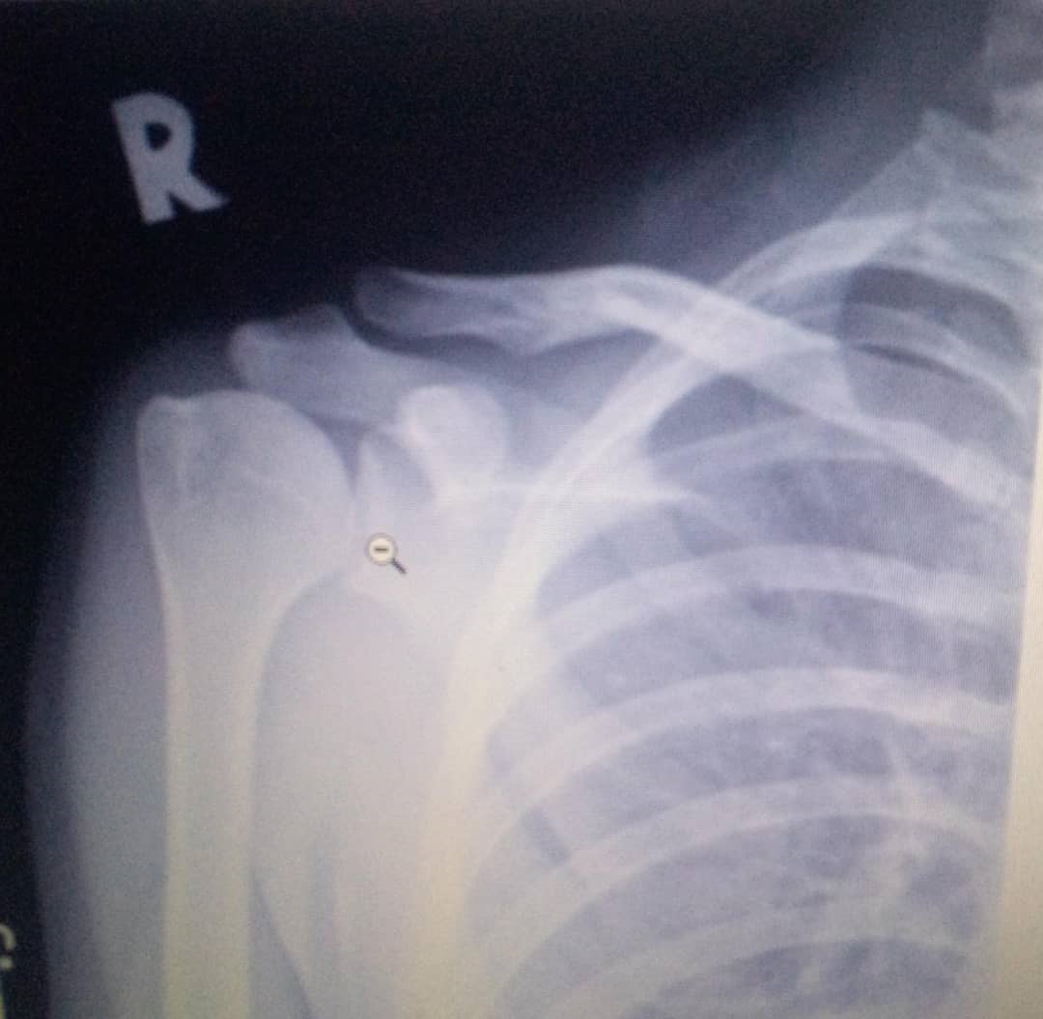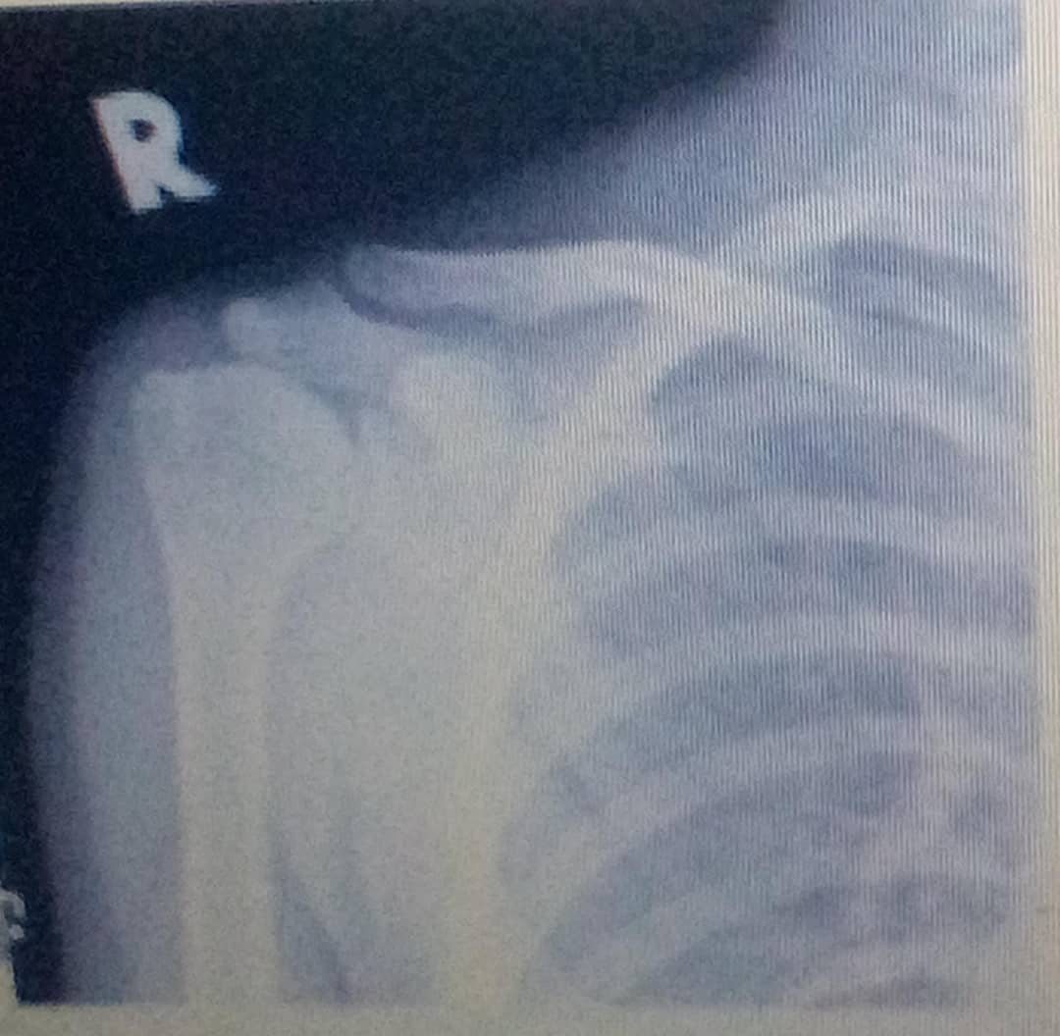

**X-ray** of

Fig----

X-RAY IS NOT SO CLASSICAL FOR DISLOCATION

Initial Treatment

Using the advanced trauma life support (ATLS) protocol ensuring that the airway, breathing, circulation of this patient was intact, he was thereafter given intramuscular pentazocine 30mg stat to relieve pain, the skin abrasion was cleaned and dressed. His right upper limb was immobilized on a collar/cuff sling and patient was thereafter taken for radiography investigation. He had x-rays of both shoulders, anteroposterior and lateral views. The x-ray of his left shoulder was done as a control. The x-ray showed an anterior dislocation of right shoulder joint as evidenced by absence of the head of humerus in the glenohumeral cavity (loss of glenohumeral joint congruity), opacity of the head of humerus more marked than the glenoid cavity.

Patient was counselled on the findings, cost implication involved in managing the injury, the diagnosis and line of treatment (closed reduction under conscious sedation, titrations iv diazepam 10mg stat and iv pentazocine 30mg stat, while monitoring the patient’s vital signs). The hospital consent form was signed by the patient.

Procedure for reduction: (Carried out by the author and a senior colleague in orthopaedics)

The modified Kocher’s method for reduction of anterior shoulder dislocation was used. Patient was positioned supine on a couch and IM pentazocine 30mg stat and IM diazepam 10mg stat was administered. A gentle increasing traction was applied to his right arm with the shoulder slightly abducted and elbow flexed while an assistant applied firm counter traction to the body through his right axilla using a folded bed sheet. A clunk sound was heard confirming the reduction. The shoulder was then adducted such that patient’s right hand was pointing towards his left shoulder.

The reduced shoulder was immobilized using a velpeau bandage.

Patient was placed on oral analgesic: Tab diclofenac 50mg bd x 2/52, then tab paracetamol 1 g tds x 5 days, Tab vitamin C 200mg tds x 3/52 and Cap. Omeprazole 20mg daily x 2/52. Why the omeprazole

A post reduction check Xray was requested for, to confirm the alignment and this was satisfactory.

Patient was counselled on the need to retain the velpeau bandage for 4 weeks. He was discharged home for follow up in clinic in a week.

Follow-up:15/12/2022. At first review, he had no complaint, and the right shoulder joint was of normal contour but mildly tender. Neurovascular examination was found to be normal. Thereafter, he was seen in the clinic weekly for four weeks. At 4th week, the velpeau bandage was removed and patient was commenced on gentle range of motion exercise across his right shoulder and elbow with the assistance of the physiotherapist and then put on a weekly appointment for His physiotherapy session. He was also advised to practice safe sex, drink wisely and be focused.

He returned to the clinic as scheduled and had no complaints. He had full range of movement and was assessed to be stable. He was discharged from the clinic after counselling on activity modification, avoiding heavy manual labour, high risk sports and boarding motor cycles with reckless riders. He was counselled on safe sex, reduce alcohol and to avoid substance abuse associated with peer pressure.

Summary: C.I was a 19-year-old male student with complaints of Pain in the right shoulder and inability to use the right upper limb. History and examination revealed shoulder dislocation and he had reduction of the shoulder dislocation with good outcome. He was educated on adolescent health promotion.

Discussion: A dislocated shoulder as seen in the index patient is an injury in which the upper arm bone pops out of the cup-shaped socket that's part of the shoulder blade. The shoulder is the body's most flexible joint, which makes it more likely to dislocate.1 Shoulder dislocations represent 50% of all major joint dislocations, with anterior dislocation being most common.1,2 Dislocations of the shoulder can be anterior, posterior or inferior, but the commonest variety is the anterior dislocation accounting for over 96-98% of cases. Anterior dislocations are of four types which include the sub coracoid, sub glenoid, sub clavicular and intrathoracic types. Of these four, the sub coracoid is the commonest.3 The shoulder can dislocate forward, backward, or downward, and completely or partially, though most occur anteriorly. Fibrous tissue that joins the bones can be stretched or torn, complicating a dislocation. Shoulder dislocation may be caused by a fall on an outstretched arm, trauma to the posterior humerus, or more frequently trauma to the arm while it is extended, externally rotated and abducted.2,4 C.I had an anterior shoulder dislocation secondary to trauma resulting from a motorcycle accident. It has been reported,5 that road traffic accident is the commonest cause of traumatic joint dislocations in Nigeria, haven recorded figures in the range of 62% - 95%. Dislocated shoulders are more likely to occur in males than in females. In males, the peak age of incidence is 20-30 years (with a male-to-female ratio of 9:1), Anterior dislocation is most seen in those aged 18-25 years due to higher activity level.4 C.I is male and is 19 years old making him fall within the age group of people highly susceptible to shoulder dislocations. At presentation, shoulder dislocation is often obvious, pre-reduction imaging for associated fractures can be useful and should be done.6 This was done for C.I. Also, in the evaluation of patients presenting with shoulder dislocation it is important to carefully examine the patient for neurovascular compromise.7 Axillary nerve injury is most common. The axillary nerve innervates deltoid and teres minor and provides sensation to lateral shoulder. Axillary nerve compromise presents in over 40% of dislocations, but usually, resolves with reduction. However, there was no axillary nerve compromise in the index patient.6,7 Premedication with intra-articular lidocaine or intravenous sedation is one of the traditional means of managing patients presenting with primary traumatic anterior shoulder dislocation in the emergency room with a closed reduction.4 C. I had im pentazocine for pain management and diazepam as anxiolytic. There are many described reduction techniques in application. Simple traction-counter is most used. However, no one technique can be recommended – thus, the physician should use whichever technique they are most comfortable with.7 The modified Kocher’s method for reduction of anterior shoulder dislocation was used for the index patient. Shoulder dislocations are best managed by an interprofessional team that also includes therapists and orthopaedic nurses. When evaluating patients with shoulder dislocations, clinicians need to be aware of the potential of associated neurovascular injury.8 Surgical management is indicated for recurrent shoulder dislocation.9 C.I did not have surgical intervention because it was not indicated in his case. The most common complication of an acute shoulder dislocation is recurrence, particularly in teenagers. Other complications are fractures, vascular injuries, and nerve injuries.8,9 C.I had none of these complications. Most uncomplicated shoulder dislocation can be managed without surgery by Family Physicians. Conservative treatment does yield good outcomes, but recurrences are known to occur in about 1-5% of patients.10

Lesson Learnt: Adolescent can be more predisposed to certain illnesses which can make them vulnerable during these difficult stages of their lives. The family physician should advocate for compulsory and consistent use of personal protective device; special boots and helmets for motorcyclist and their passenger and also continuously enlighten on safe cycling. They should endeavour to identify the developmental stage of their patients with the aim of helping them cope through the challenging period.

References

1. Enger M, Skjaker SA, Melhuus K, Nordsletten L, Pripp AH, Moosmayer S, Brox JI. Shoulder injuries from birth to old age: A 1-year prospective study of 3031 shoulder injuries in an urban population. Injury. 2018;49(7):1324-1329.
2. Abrams R, Akbarnia H. Shoulder Dislocations Overview. [Internet] Available from: <https://www.ncbi.nlm.nih.gov/books/NBK459125> Assessed on 4th June 2022
3. Eyimina P. D., Echem R. C. Shoulder Dislocation in the course of Revenue Collection: A Need to Caution Revenue Agents in Port Harcourt. The Nigerian Health Journal, Vol. 10, No 1-2, 2010. Not vancouver
4. Edomwonyi EO, Nwokike OC, Onuminya JE. Management of traumatic joint dislocations in Irrua. Surgical Science. 2015 ~~Jan~~;6(3)15
5. Onyemaechi NO, Eyichukwu GO. Traumatic hip dislocation at a regional trauma centre in Nigeria. Nigerian journal of medicine. 2011;20(1):124-30.
6. Roberts S, Dearne R, Keen S, Littlewood C, Taylor S, Deacon P. Routine X‐rays for suspected frozen shoulder offer little over diagnosis based on history and clinical examination alone. Musculoskeletal Care. 2019 ~~Jun~~;17(2):288-292.
7. Srinivasan S, Pandey R. Current concepts in the management of shoulder instability. Indian journal of orthopaedics. 2017 ~~Oct~~;51:524-528. Not complete
8. Farrar NG, Malal JJ, Fischer J, Waseem M. An overview of shoulder instability and its management. Open Orthop J. 2013;7:338-346. Check for issue number
9. Gurney-Dunlop T, Eid AS, Old J, Dubberley J, MacDonald P. First-time anterior shoulder dislocation natural history and epidemiology: immobilization versus early surgical repair. ANNALS OF JOINT. 2017 ~~Nov~~ 1;2. Not complete
10. Olds MK, Ellis R, Parmar P, Kersten P. Who will redislocate his/her shoulder? Predicting recurrent instability following a first traumatic anterior shoulder dislocation. BMJ Open Sport Exerc Med. 2019;5(1):e000447.

Get the 11th reference if possible